It truly is a winnable war!

Hundreds of thousands of your fellow strugglers on five continents have attended the live seminars. Countless others have listened to the audio presentations. Now you can study for yourself the well-tested tool for becoming an Ambassador of Purity in your home, your church and your community, regardless of where you live. Introducing:

The Purity War: A Biblical Guide to Living in an Immoral World
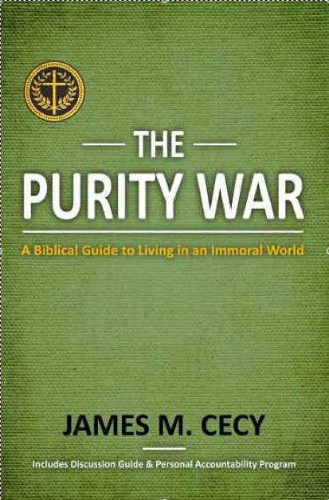
Be equipped to win the purity war—from a thorough presentation of Scripture, church history and from Dr. Jim Cecy’s four decades of ministry. With great sensitivity, biblical clarity, and pastoral passion, he presents:

• the need for personal purity in an immoral world.
• the fallacy of the “new morality”—the old immorality with a new name.
• God’s design for sex as an expression of His oneness.
• the steps down to the devastating results of moral failure.
• the lines of defense in the daily battle with immorality.
• how to guard your mind, your body and each other.
• how to be made right with God, yourself and others.
• how to start a revival of purity that lasts for generations.

Includes a detailed Study Guide and an extensive Personal Accountability Program for personal reflection or group study. This book is really two books under one cover: 250 pages of content and a 150-page Study Guide with detailed helps.

What others are saying about The Purity War

“Dr. Cecy’s The Purity War is phenomenal! Beautifully written, and strikingly persuasive. This book is full of candid and compelling illustrations, and unique insights into the Scriptures. More than a guide to moral purity in an immoral world; it is a straight-to-the heart invitation to radical Christian obedience that will transform life on every level. It is a book we will get behind, and circulate around the globe.”
—Dr. David W. Dorries, Academic Dean and Professor of Historical and Theological Studies, Oslo International Bible College, Oslo, Norway

“Excellent from cover to cover. . . . I may make it required reading for all the men at our church. Thoroughly biblical. Thoroughly insightful. Thoroughly convicting. Thoroughly practical. And thoroughly redemptive. This book is a must read!”
—Pastor George Posthumus, Senior Pastor-Teacher, Riverpark Bible Church, Fresno, California

“The Purity War provides a biblical foundation for understanding and overcoming the struggle of soul in sexual matters. Thoughtful, practical, and encouraging, Dr. Cecy offers a clear strategy for holiness. If there is one book to read on this subject, you are holding it in your hands.”
—Pastor Gregg Cantelmo, Bridgeway Community Church, Phoenix, Arizona

“From his heart to ours, Pastor Jim Cecy has poured his life message into this book. It is written with passion and conviction overflowing from his ministry focus of the last two-plus decades. While so many Christians are straying from God’s standards, this book is a clarion call to righteousness—like the voice of a prophet, calling us back to God.”
—Dr. Ken Royer, Director of Pastoral Counseling, Link Care, Fresno, California

“Pastor Jim Cecy goes far beyond equipping and teaching about personal purity; he goes to the very heart of the matter. For many years I have witnessed how numerous lives have been impacted by the biblical principles taught through his seminars. Every Christian can have these solid and practical guidelines as a personal manual . . .”
—Pastor Joby Soriano, Christ’s Commission Fellowship, Manila, Philippines

“The Purity War equips us to march together with our fellow Christian soldiers and to win this battle with a combat knowledge of the Word of God.”
—Pastor Gil Harder, Missionary to Africa, JARON Ministries International

“This is a refreshing treatise on the Biblical call to personal purity.”
—Dr. Darryl Delhousaye, President, Phoenix Seminary, Phoenix, Arizona
“Dr. James Cecy has set forth a biblical blueprint on sexual purity that will greatly benefit men as well as women in the body of Christ. Dr. Cecy has consistently taught on this subject in seminars all around the world. I believe he is the leading Christian authority on this issue. He has exemplified this truth in his own life and has been an inspiration to me and other Christian leaders to be ambassadors of purity in our own lives and ministries. I had the privilege of teaching this material to church leaders in central India where the positive response was overwhelming, even among the women. May God be glorified through the distribution and reading of this book. May it bring about repentance, renewal and the refreshing of zeal for the holiness of God within the Church.”
—Dr. Randall L. Brannon, Senior Pastor, Grace Community Church, Madera, California and Adjunct Missionary, JARON Ministries International

“Reading through The Purity War is a fresh reminder of what we learned in the live seminars. I especially appreciate the connection between theological accuracy and practical application. Dr. Jim Cecy’s personal concern for those who are struggling is apparent. I am really looking forward to the book being translated into Czech for I know that many are struggling with the issues he addresses.”
—Peter Lupton, Church Planter, Svitavy, Czech Republic

“This book is different! The world of Christian publishing has recently produced piles of books on sexuality and purity. Many of these volumes exchange scriptural perspective for personal testimonies and descriptions of the battle for purity that can border on voyeurism. The biblical description of the cause of moral failure and the practical plan of attack laid out in Part Three through Five will make this book a valuable tool in the believer’s library. “
—Pastor Justin Greene, Senior Pastor, Salem Heights Church, Salem, Oregon

“This book on purity was very readable and I enjoyed the way it flowed and challenged me as I read it. Because of the balance between biblical content and relevant illustrations, the book was clear and personal. In several places it was academic, however it needed to be to fully explain the text. The entire book held my interest and the worksheets at the end of the book were very helpful and relevant. It should translate well into any other language. This book is a “must read” for all ages. Pastor Jim Cecy has taught these principles for many years, but even more importantly, has lived out these principles in his own personal life. The balance between biblical truth and practical application is extremely helpful. This is one the most reliable and relevant books written on the subject of purity.”
—Pastor Ron Schafer, Executive Director of S.T.E.P.S., Monument, Oregon

“The Purity War: A Biblical Guide to Living in an Immoral World is a very practical guide to living with purity in today’s world. Dr. Cecy writes with refreshing honesty, giving personal examples of both success and failure, and interweaves it all around the centrality of Scripture for our central focus, reference, and commitment. With the included Study Guide and Personal Accountability Program, there is a wealth of resources for immediate application. This book should be part of each of our personal library for our own purity journey, as well as a reference for those we work with, whether it be in church, school or counseling setting.”
—Dr. Brent Lindquist, Clinical Psychologist and President, Link Care Center, Fresno, California

“This book obviously comes from one who is deeply concerned for people’s well-being. It is eminently timely since our society is plunging toward its demise in large part because of flouting our Creator’s ways. It may be ‘too little too late’ for society as a whole, but it can certainly help many individuals avoid, and many others find significant healing from violation of basic sexual morality.”
—Dr. Gary Tuck, Professor of Biblical Literature and Academic Coordinator, Western Seminary, San Jose, California

“Open. Direct. Highly useful. The Purity War is a living text, filled with rich examples from Scripture and personal testimonies. It is a highly useful and much-needed book, especially in Eastern Europe where the sexual revolution has resulted in our part of the world becoming a major center for the sex-trade industry and 65% of all pregnancies ending in abortion.”
—Jaroslaw Lukasik, Director of the Eastern European Leadership Forum

“James Cecy’s book The Purity War powerfully addresses one of the most important topics in the world wide church – purity and holiness. I read chapter after chapter of biblically rich and insightful insights and was convicted time and again. This is a wonderful book which caused me to turn to the Lord and his Word. I am convinced that every Christian leader should read this book first for their own walk with the Lord and then read it again to learn how to help others. Jim has been teaching this content across Europe and is powerfully being used by the Lord to inspire and teach thousands to a closer walk with the Lord!”
—Dr. Greg Pritchard, Director, European Leadership Forum and Communication Institute, Lisle, Illinois

“I have no advanced degrees. No fancy titles. However, I am married to the man who wrote this book. I have seen these sound biblical guidelines and practical principles work in his life for forty years of marriage. I can think of no higher endorsement.”
—Karon Cecy, Jim’s wife
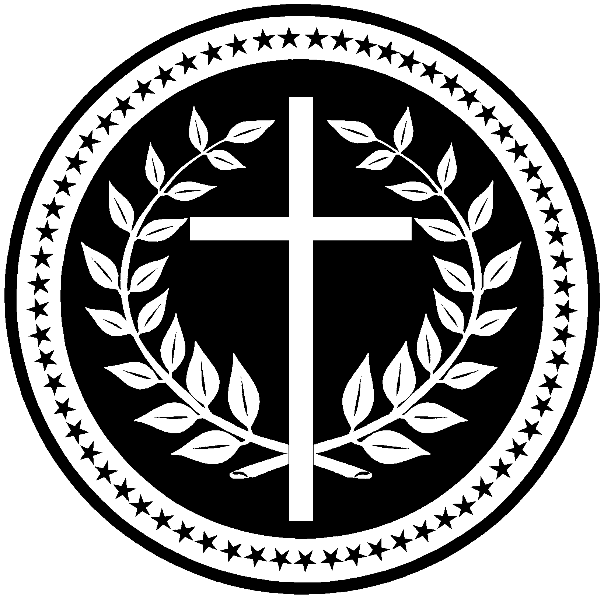
Available through www.condeopress.com

$24.95 plus shipping

Special group rates and bulk discounts available

